Press Release
Munich, 5th of July 2023

EMO 2023: End-to-end quoting solution enables CNC machine shops to calculate prices automatically and increase efficiency by up to 90%
Quoting made effortless with Spanflug
Spanflug will present its automated quoting solution for CNC machining companies at EMO 2023 in Hannover, Germany. Spanflug Make automates the calculation of manufacturing times and prices for custom machined parts. The latest, extended version presented at the EMO is an end-to-end quoting tool for the entire process – from receiving RFQs to sending out final quotes to customers. The seamless, digital solution will help manufacturing machine shops and job shops to boost efficiency and stay competitive. The Munich-based technology company will present these and other innovations at the exhibition’s Future of Connectivity Area in hall 9, booth H22.
Effortless start into automated quoting
Spanflug Technologies will present its quoting solution in its latest version at EMO 2023. The cloud-based software aims to streamline the otherwise complex and tedious process of preparing quotes for custom turning and milling parts and reduces efforts by up to 90%. It addresses the challenges faced by machine shops, such as excessive time and cost spent on administrative tasks, increasing competitive pressures and uncertainty resulting from the growing complexity in stocks procurement. With its industry-leading, innovative algorithm, Spanflug Make sets new standards in automated quoting.
Seamless digital solution from CAD model to ready-to-send customer quote
With Spanflug Make, machine shops calculate prices for turning and milling parts in one minute. The software supports throughout the entire quoting process – from receiving RFQs to sending out final quotes to customers. Main features of Spanflug Make include:

- Leading software technology automatically extracts all data relevant for manufacturing from CAD models and technical drawings, which users can securely upload. Spanflug’s smart parts analysis eliminates the need for manual data entry and enables also employees without technical know-how to prepare precise customer quotes easily and autonomously.
- Prices and manufacturing times are automatically calculated by the intelligent Spanflug algorithm, which has been tested on hundreds of thousands of parts and is subject to continuous AI-based and data driven improvements. It also includes up-to-date prices for nearly 60 materials and over 30 post-treatments, helping to reduce uncertainty in current supply chains and to achieve the calculated margins despite price fluctuations. Details, such as machining times, stocks or tools needed, are also provided and support machine shops in manufacturing planning.
- The software can either be used out-of-the-box or customized for the individual machine shop in just a few simple steps by setting up CNC machines and adjusting settings such as cutting values or markups.
- As an end-to-end quoting tool, Spanflug Make increases the efficiency of the entire quoting process. It is designed to suit a wide range of operational settings – from larger companies with established IT systems to smaller machine shops at the beginning of their digitization journey. The solution includes possibilities to manage customer master data directly within Spanflug and to either export calculation results to existing ERP systems or to conveniently generate a quote.
- Spanflug Make is a software-as-a-service solution that can be used without installation and maintenance efforts. Calculating five parts per month is permanently free, while monthly or annual software subscriptions are available for unlimited calculations.

Digital processes as competitive advantage
"With Spanflug Make, we support machine shops throughout the entire quoting process, allowing them to fully focus on manufacturing," emphasizes Dr. Markus Westermeier, CEO and Co-founder of Spanflug. "Machine shops can easily implement and configure our solution with minimal effort and benefit from day one. With our efficient, digital processes, they become more competitive and future-proof. Calculating and generating quotes in one comprehensive tool provides even greater time, effort, and cost advantages."

From September 18th to 23rd, 2023, Spanflug will showcase these and further innovations of its digital manufacturing platform at the world’s leading trade fair for production technology in Hannover. "Our booth is well placed in the ‘Future of Connectivity Area’," Westermeier is looking forward to EMO. "Connectivity, digitalization and automation are inevitable steps for manufacturing companies to stay competitive amid increasing cost pressure and the complexity of today’s international market developments." Trade visitors and press representatives can find Spanflug at booth H22 in hall 9. For further information visit: https://spanflug.de/en/emo.
4.866 signs incl. spaces

To download high resolution images to accompany the publication of this news, please visit the media section at https://spanflug.de/en/emo or contact our press team at press@spanflug.de.
1. Cover image:
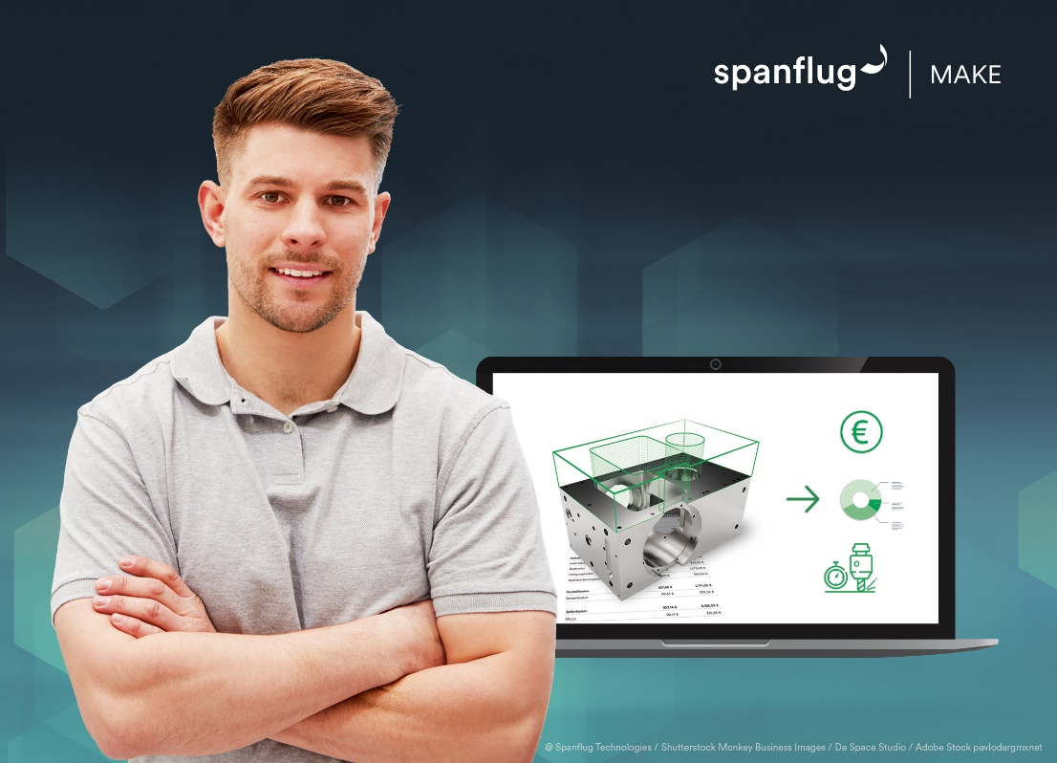
Caption: As an end-to-end quoting solution, Spanflug Make frees manufacturing companies from time-consuming administrative tasks throughout the quoting process.
Source: Spanflug Technologies / Shutterstock Monkey Business Images / De Space Studio / Adobe Stock pavlodargmxnet

2. Infografics:
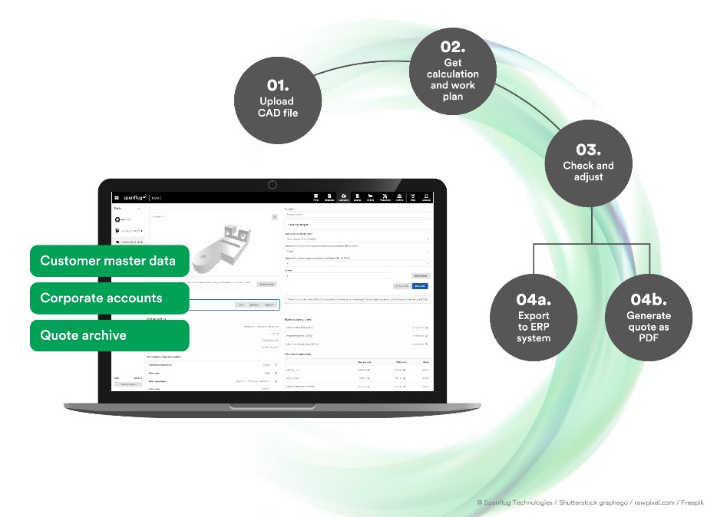
Caption: Seamless digital solution for CNC machine shops from CAD model to ready-to-send customer quote.
Source: Spanflug Technologies / Shutterstock graphego / rawpixel.com / Freepik

Contact information for press inquiries:
Spanflug Technologies GmbH
Antje Hollis
Lindwurmstr. 76
80337 Munich, Germany
email: antje.hollis@spanflug.de
Telefon: +49 89 21555438 16

Website: https://spanflug.de
LinkedIn: https://de.linkedin.com/company/spanflug
Instagram: https://www.instagram.com/spanflug/
About Spanflug
Spanflug Technologies GmbH is a Munich based technology company and operator of a manufacturing platform for CNC turning and milling parts. The mission of Spanflug is to advance the digitization of the manufacturing industry by making the time-consuming process for the procurement of custom machined parts as quick and easy as possible for both customers and suppliers. The digital procurement solution Spanflug Buy offers a fast, automated purchasing process to customers – from instant quote to delivery on the desired date. The parts are manufactured via a network of over 5,000 CNC machines at qualified suppliers in Germany and Austria. Spanflug Make enables manufacturing companies in the machining sector to boost the efficiency of their administrative processes from quoting to purchasing, so they can focus on their core competence in machining. The company is a spin-off from the Institute for Machine Tools and Industrial Management (iwb) at the Technical University of Munich (TUM). Spanflug is supported by the Initiative for Industrial Innovators. Since 2020 the VDW (German Machine Tool Builders’ Association) is a shareholder of Spanflug. Further information can be found at spanflug.de/en.

